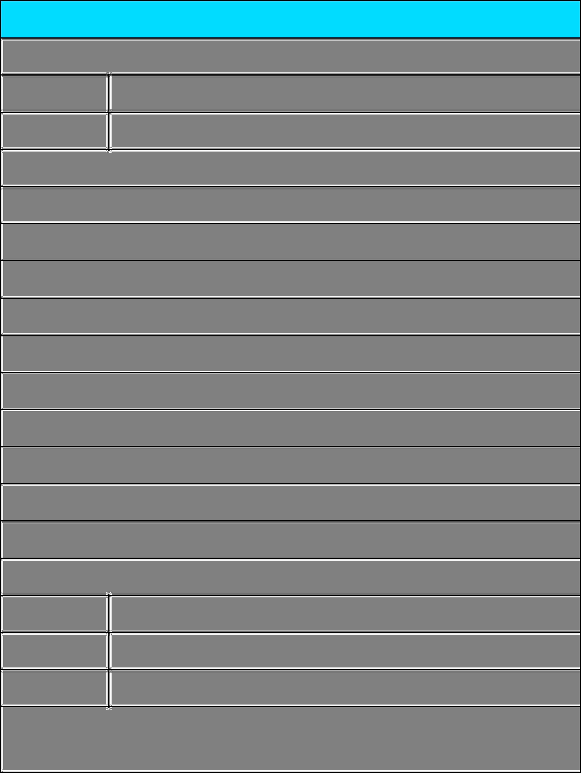**Rent Receipt Template**

**1. Employee details**

Employee ID : **2525756**

Full Name : **Divyarajsingh Siyaram Mandale**

**2. Address of the rented house**

CITY : **Manohar Bhai Waard,** **Gondia**

STATE : **Maharashtra** PIN CODE : **441614**

**3. Rent details**

Received with thanks from (employee name) Mr./Ms : **Divyarajsingh Siyaram Mandale**

sum of Rs : **16000**

(Rupees **Sixteen Thousand** only)

towards the rent of the above mentioned residential premises for the month of **March 2024**

Mode of Payment (Cash/Cheque/Online) : **Cash**  Payment Dated : **01/03/2024**

**4. Landlord Details**

Permanent account number (PAN) : **FXRPM8574A**

Full Name : **Yogeshwari Maheshkumar Mandia**

Landlord Signature 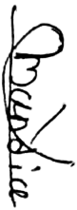

and Date **01/03/2024**

